Introduction
Branding is one of the essential elements in the organizational/company business strategy. Branding also include business name, logo, symbol, package design etc. In business marketing, branding also considered as an advertising element of the organization or a company. However, majority of the business owner including business managers have a perception that the aspect of branding is all about the managing the image of the product which an alternative means that is very different from the management of business products. Branding could be expensive, valuable, continuable and also destroyable. In fact, it is more easier to destroy your brand compare to building one，Volkswagen is one of the significant example of destroying their brand by dishonest. However, this paper explains the various strengths and weakness of the branding in Sephora stores, including the perceptions that provide an argument on branding.
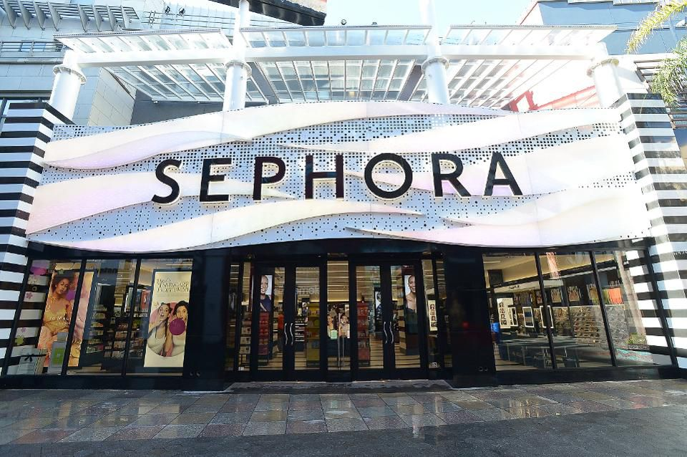
Firstly, it is a strategic point used by Sephora stores to display their products in the field of market. Also, Sephora stores used branding as a central point of adding customers' value to their products but not an issue of displaying their products images. In addition to the other strengths, branding is a primary tool that creates and maintains its competitive advantage in the market. Generally, branding is like a business culture that moves around many business organizations and companies. For example, when I walk in the Sephora stores, there lay out are mostly the same, which you know where to get the stuff you usually wanted. Despite the many strengths, there is also some weakness associated with branding, particularly to the Sephora store. To mention a few, it is costly and time consuming.
In the case, it requires a substantial and expansive advertisement, beautiful packages as well as effective sales and promotions, which is a bit threshold to the Sephora stores. This is because creating up brand recognition and loyalty to its customers is very expensive, especially with Sephora stores. For instance, when I walk in Sephora store they have got many features, including a variety of beauty items ranging to over three hundred different brands of products. Which provide me a good experience shopping around because its organized, and a lot of choice. These products include the ladies make-ups, urban decay, the benefits cosmetic, first aid beauty and many others. Also, Sephora stores offer their own produced make-ups like skincare services, beauty tools as well as accessories. Therefore, all these branding requirements subject considerable expenses and cost to the Sephora stores. But this branding strategy reduces the risks in product decisions for customers, since there are a lot of fake product in the market, Sephora’s brand does protect customer from getting fake item, which create value and population, this is one of the reason why I choose Sephora.
Strengths of Sephora Store Branding
One of the strengths of Sephora, which is a beauty and cosmetic stores receive from branding their products is a competitive advantage. Sephora stores have powerful branding techniques to their beauty and cosmetic products, which gives them a good competitive advantage to their counterparts. The benefits they receive as a result of their branding techniques do not only rely based on customers, but also it provides a channel for negotiation with their respective partners. It has an influential branding culture that offers them with considerable control informing policies, therefore, giving them powers to influence and negotiate with their retailers. The varieties of brands associated with Sephora stores across the world is the reason behind its exceptional achievement in the sale of beauty and cosmetic products.
In marketing, it is believed that customers have little or no interest in the tangible nature of the products or excellent services. Still, they are more interested in other components like the outlook of the product they have to use, which is probably an image that is impressive and attractive to them when they use the brand item. Hence, with Sephora, having a variety of products brands, they have an excellent opportunity to attract more customers who will have the chance to select the brand they are interested in using. This provides a boost to Sephora stores by collecting high incomes from the many buyers they attract from their different brands which are contrary to their competitors. For the Sephora stores, the advantages that the branding process creates originates from its distinguished products from the ones of their competitors in an unusual way, which is essential for the customers and service providers. Also, their branding helps in increasing the value and perception of their beauty and cosmetic products. A competitive advantage emerges where they have high chances to release new items to the market more accessible and efficient. For instance, the picture below shows the inside look of the Sephora mall in America. It has a variety of brands, especially for beauty and cosmetics, including the beauty studio.
When I physically in the Sephora stores of UTC, I can feel the power of branding. First, its very organized with color white and black which match with there name. White is associated with light, goodness, innocence, purity, and virginity. It is also considered to be the color of perfection, and black is associated with power, elegance, evil and mystery. When putting it together it makes a remarkable vision for customer to remember it. Also, when I work in the UTC mall, I don’t even need to look for Sephora store’s name, the only things I need to look for is color white and black on the door. Which is consider as Brand image. Second, they have a very good packaging which is another important elements of branding, they just simply use black and white lane in their packaging, but we can recognize it immediately its Sephora. When I saw people walking in the mall with black and white lane bag, I know there are Sephora somewhere in the mall. Third, the stores it’s very similar to most of the other Sephora store I had visited which give a great experience on finding product I want. Sephora stores offer excellent services to their customers that are beyond usual services including hi-touch activations such as the demos and makeovers, as well as incentivizing their customers through overwhelming loyalty creativities such as Beauty Insider Rewards, which is a tactic that allows their customers gain more points and be given freebies. This is a good combination with Retailers and services in a store. And one of the best experience I received especially promotions where I earned more points and I was a warded freebies.
In Sephora stores provide exemplary sensory involvement with fresh music, qualified services providers, and samples. It makes use of its availability to offer hands-on services to their customers. Their different workshops across the world provide their customers with tremendous and impressing makeovers from their experts' styles. Also, they have touchscreens where their customers can test their preferences. In brick-and-mortar store locations like the one in UTC, they have enough space where their customers can watch tutorials on make-up and select products they are interested in purchasing.
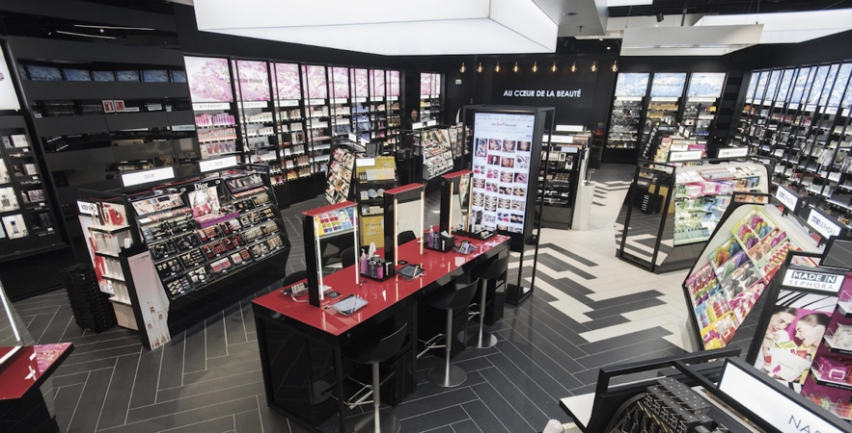
The image below shows Sephora’s stores that are located at the Middle East, which is an internationally stock store that has legendary beauty and cosmetics products such as the Clinique, L’Oreal and the Estée Lauder and other varieties of brands. A businesswoman named Huda Kattan founded Huda Beauty, which is a typical branch of the American Sephora mall, and at that time it was the store with high selling of beauty and cosmetic brand across Sephora Middle East.
Still, on competitive advantage as the strength of Sephora store branding, their branding technique offers more values to their products even from the time of launching the new products in the market. My point of view is that branding is a technical strategy in business and marketing that requires step by step development for it to be beneficial and influential. It is associated with some functional branding components as well as their skill of implementing them through marketing techniques, analysis of feedback based on market and communications about the brand from customers while considering the requirements of the market. Otherwise, it is very significant that the branding techniques and procedures should serve the main objectives of the business organization or a company just like Sephora stores both in the short and long term marketing strategy.
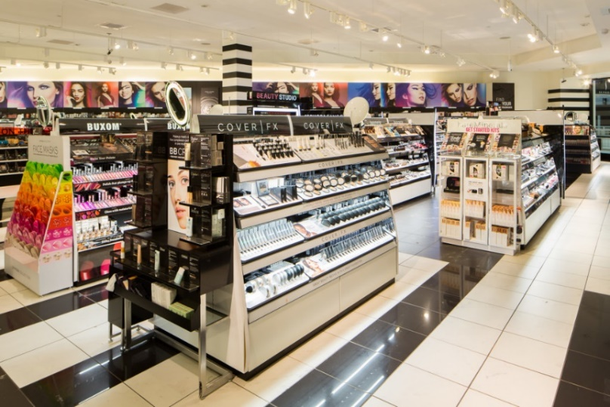
Branding also serves as a symbol for expressing the identification and values of the product. In the past, people used to depend on their material cultures like clothes, natural ornaments and religious icons that acted like material makers of production values as well as identity. The establishment of Sephora stores has led to the emergence and development of varieties of beauty and cosmetics in the current market field across the world. They offer many types of consumer goods that dominate in most parts of the world that serve mainly function to women beautification. Particularly, branding has a lot of powers to our current societies. It is used to express people’s lifestyle, social status, aspirations and other social identities which Sephora stores placed its great focus. That shows Sephora have very clear target market and positioning.
For instance, Sephora stores became great producers, sellers and distributors of beauty and cosmetic products in America, which was its ideal of achievement and perseverance. They are also the great innovators, rebellious, and creative by producing different brands of their products that gives values which are associated with the movement of the world economy. For that reason, Sephora stores display symbolic values in their products that make them have conventions in their brand culture that exerts substantial effects, particularly to the other types of brand value from other companies.
The weakness of Sephora Stores Branding
Despite the many strengths that Sephora stores have in the market field, they also have flaws that discourage their customers as well as affecting its general operations. One of the weakness is the pricing policy. Due to a variety of specialized products and services they provide to their clients, it has made them set higerh prices to their services and commodities, which makes them unfordable to some of the users. Their pricing decisions, especially to most of the goods and services offered to the public, usually have adverse implication to the economy. When I was in the stores, I usually saw people compare pricing online and in store, which I will do too, and usually the price online are cheaper. That leads to customer will only purchase there product in store because they want it immediately.
Even though they aim to offer products of high value, their pricing also poses a strong branding effect. For instance, their pricing policies can be specifically focused on profit maximization from their products and services. This discourages most of the customers, especially those who are not financially stable, thereby making them select products and services from other stores. Correspondingly, there are different pricing policies which consumers recognize as gouging. This is a price discrimination contrivance which is after taking advantage of their customers, and it leads to narratives of an uncaring and self-centered company that would, in turn, put an end to their relationship values with their primary customers. But on the other hand, it also give the opportunities to use promotions strategy which can make customer feel the price are dropping and its wroth to buy.
Stiff competition is another weakness faced by Sephora stores. Sephora is at the edge of competing against other companies like the Ultra, and Marcy, who are one of the biggest sellers of beauty and cosmetics products. This can force Sephora to change their marketing strategy and employee, many incentives like trade discounts because the market field is more competitive. It is because of the increased demand and supply that have created a competitive environment making it more intensive. When I walk into Sephora often see many discounted, as well as their online store. Based on demand, consumers have reduced due to increased supply of products and services, therefore, creating a weak market ground. Sephora can only attain a slight increase in sales of their brands just by taking away the market share of their competitors.
Inadequate capitalization is also another significant weakness facing Sephora stores. This is directly proportional to the small sales they make, especially when they are compared to their counterparts like the Ultra, and Marcy and Companies who make big sales yearly. For instance, Marcy has a large amount of capital availability which causes it to be more effective and efficient in its operations, therefore growing and expanding rapidly than other companies. Also, it gives the Paris beauty and cosmetics company more significant publicity to America as the second leading region by sales after Asia.
Conclusion
Branding strategies and techniques that are more powerful in the beauty and cosmetics market field frequent change over time. In this new media environment, traditional ad media seem to lose their grip. Many companies are creating website platforms to advertise their products and services regularly which capture the attention of people from different parts of the world. However, companies have placed their focus on media which has a significant influence on the people, and they are very appealing and attractive, for example, WebMD. Even though, Sephora does a great job on branding there name, which met the criteria that are memorable, meaningful, likable, and protectable. Consumers are at the wheel, and most of them are changing their test and preferences regarding how it is displayed on the site platform. So, companies, including Sephora, should improve their branding efforts and concentrate on consumers by massive advertisements. Thinking about this way, did you usually saw Sephora’s Advertisements when you steaming online? Or often saw it in your daily life? I think the answer is No. Advertisements can help them gain more strengths, reduce their weaknesses, increase flow, and enhance people’s perception of strength of Sephora, which will pave the way for them to emerge as the best sellers of cosmetics products across the world.

Reference:
Picture 1: Source: https://thumbor.forbes.com/thumbor/960x0/https%3A%2F%2Fspecials images.forbesimg.com%2Fdam%2Fimageserve%2F948753524%2F960x0.jpg%3Ffit%3Dscale
Picture 2: Source: https://www.criteo.com/wp-content/uploads/2018/12/sephora.png
Picture 3: Source: https://markteskeyarchitecture.com/wp content/uploads/2015/10/A2008_Sephora_MOA 13-1024x683.jpg

